**EXERCISE NO: 10**

**DATE: 22/11/2020**

**AIM:**

To calculate the number of upper case letters and lower case letters.

**PROGRAM:**

def string_test(s):

d = {"UPPER_CASE":0,"LOWER_CASE":0}

for c in s:

if c.isupper():

d["UPPER_CASE"]+=1

elif c.islower():

d["LOWER_CASE"]+=1

else:

pass

print("No. of Upper case case characters : ",d["UPPER_CASE"])

print("No. of Lower case case characters : ",d["LOWER_CASE"])

s = input()

string_test(s)

**OUTPUT:**

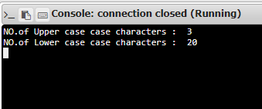

**LINK:** [**http://103.53.53.18/mod/vpl/view.php?id=325&userid=1695**](http://103.53.53.18/mod/vpl/view.php?id=325&userid=1695)

**RESULT:**

Thus upper and lower case characters are displayed for the given string.